SWE20004 Technical Software Development Semester 2 2019

Assignment 1 report

Name: Gamaliel D’mello Student ID:102117407

Lab class: Thu / 12:30 – 2:30 / EN402 Tutor: Kai Renshaw

Due Date: Friday 6th September 2019 at 11:59 pm

Date Submitted: Wednesday 29th August 2017 at 11:59pm

Assignment Title: 1

Program description

This Program Allows the User to Encoded And decode a number that has at least 2 digits and a max of 8, allowing for extra encryption for 8 numbers

Inputs and Outputs
The inputs and outputs for this program are described in Table 1.

Table 1. Data dictionary:
Data to be stored | Sample data | Type of data | C++ type | Input method | In /  Out | Variable name
The Value to be enter to exit the program | -1 | Integer | Int | N/A | Cout | ENDCODE
Choice | 1 | Integer | Int | Cin | Cout | Choice
Number User Enters to be encoded | 12345678 | Integer | Int | Cin | Cout | Userum
The amount of digits in the Number entered | 8 | Integer | Int | cin | out | Digit
The Encoded Value of the number entered | 41852963 | Integer | Int | Assignment | Cout | Encoded
The Decoded value of the number taken from the encoded value | 12345678 | Integer | Int | Assignemtn | Cout | decoded
The answer taken from user for their answer | Y or N | Character | Char | Cin | Cout | Ans
A true or false statement depending of the user selected for the extra protect | True or false | Boolean | Bool | Assignment | Assignment | ExtraProtect
Checks if the user Answer is correct and if it is it will be set to true (Used to exit the loop) | True or false | Boolean | Bool | Assignement | Assignment | isAns
Checks if the Number is correct and if it is it will be set to true (Used to exit the loop) | Ture or false | Boolearn | Bool | Assignemtn | Assignement | IsError
A dynamically created array that hold the individual digits in the number inputted | Array[0] = 1  Array[1] = 2 | Array | Int *Variable[value] | Assignemtn | Assignement | numArray
A temporary variable used to swap the numbers | 0 | Integer | Int | Assignemtn | Assignment | temp
A value that puts the array back into a single int | 12345678 | Integer | Int | Assignement | Cout | append

3. Algorithm
Program steps:
- Enter 1 to start enter Number
- Enter 2 to 8 digit Number
- If number to small return error message and loop back to step 2
- If number too big return error message and loop back to step 2
- If number is 8 digits prompt for extra protection
- Encode value
  - If 2 digit swap them
  - If 3 digits swap first and last
  - If 4 get the mod of 3 times the number
  - If extra protect do 6c and then swap the 1&8,2&7,3&6, 4&5
- Prompt to decode
  - If digit is 2 swap
  - If digit is 3 swap last and first
  - If 4 digits use the numFind to get the value of the original based on the unique number
  - If extra protect first swap the number doing the opposite of 6d and then do step 7c
- Print to screen the digits, the encoded value and if selected the decoded value

Coding logic:

While digit is not 0
number = number %10
Numberarray = Number
number /= 10
if digit is 2
swap array1 and array 2
append = 10* append + array

if digit is 3
swap array1 and array 3
append = 10* append + array

if digit is >4
(number*3) mod%10
if extrapotect is true
swap 1 & 8
swap 2&7
swap 3&6
Swap 4&5

Decoding logic:

While digit is not 0
number = number %10
Numberarray = Number
number /= 10
if digit is 2
swap array 2 and array 1
append = 10* append + array

if digit is 3
swap array3 and array 1
append = 10* append + array

if digit is >4
if num is 1
num = 7

if num is 2
num = 4

if num is 3
num = 1

if num is 4
num = 8

if num is 5
num = 5

if num is 6
num = 2

if num 7
num = 9

if num is 8
num = 6

if num is 9
num = 3
if extrapotect is true
swap 8 & 1
swap 7&2
swap 6&3
Swap 5&4

if num is 1
num = 7

if num is 2
num = 4

if num is 3
num = 1

if num is 4
num = 8

if num is 5
num = 5

if num is 6
num = 2

if num 7
num = 9

if num is 8
num = 6

if num is 9
num = 3

Source code:

/*Name: Gamaliel D'mello
Student id: 102117407
File name: 102117407_Assignment1
Purpose: A console Application that takes in a number that has digits between 2 and 8 and encodes and decodes it
*/

#include <iostream>
#include <string>
#include <cmath>

//Function decleration
int menu();
int getNum();
int numSeperator(int number);
int encoder(int number, int digit, bool ExtraProtect);
int decoder(int encoded, int digit, bool ExtraProtect);
int numFind(int Num);

using namespace std;

/*Main gets users Choice and
does validation and calls functions to encode
and/pr decode the value*/
int main()
{
const int ENDCODE = -1;
int choice, userNum, digit, i = 0, encoded, decoded;
char ans;
bool extraProtect, isAns = false;

do
{
extraProtect = false;
choice = menu();

if (choice == 1)
{
userNum = getNum();
digit = numSeperator(userNum);

if (digit == 8)
{
cout << "Do you want Extra protection (y or n): ";
cin >> ans;

do
{
if (tolower(ans) == 'y')
{
extraProtect = true;
encoded = encoder(userNum, digit, extraProtect);
isAns = true;
}
else if (tolower(ans) == 'n')
{
encoded = encoder(userNum, digit, extraProtect);
isAns = true;
}
else
{
cout << "Please make a choice based on the following(y or n): ";
cin >> ans;
}
} while (isAns == false);
}
else
{
encoded = encoder(userNum, digit, extraProtect);
}

cout << "Do you want to Decode (y or n): ";
cin >> ans;

do
{
if (tolower(ans) == 'y')
{
decoded = decoder(encoded, digit, extraProtect);
cout << "Digits Contained " << digit << endl;
cout << "Encoced value is: " << encoded << endl;
cout << "decoded value is: " << decoded << endl;
isAns = true;
}
else if (tolower(ans) == 'n')
{
cout << "Digits Contained " << digit << endl;
cout << "Encoced value is: " << encoded << endl;
isAns = true;
}
else
{
cout << "Please make a choice based on the following(y or n): ";
cin >> ans;
}
} while (isAns == false);
}
else if (choice == ENDCODE)
{
cout << "Program has ended Sucessfully";
}
else
{
cout << "This is an invalid Choice Please input a different Choice" << endl << endl;
}
} while (!(choice == ENDCODE));

return 0;
}

/*Menu to give user the options*/
int menu()
{
unsigned int choice;
cout << "Enter 1 to Input your Number" << endl;
cout << "Enter -1 to exit program" << endl;

cin >> choice;

return choice;
}

/*gets the User Number and checks if it is
valid (Between 2 and 8 digits)*/
int getNum()
{
unsigned int number;
bool isError = true;

cout << "Enter Your value (range 2 - 8 digits): ";
cin >> number;

do
{
if ((number >= 0) && (number <= 9))
{
cout << "Please Enter a double Digit Number: ";
cin >> number;
}
else if (number > 99999999)
{
cout << "Number has to be less than 8 digits: ";
cin >> number;
}
else
{
isError = false;
}
} while (isError);

return number;
}

int numSeperator(int number)
{
int digit = 0;

while (!(number == 0))
{
number /= 10;
digit += 1;
}

return digit;
}

/*Get the user value and the amount of digits
if the digit is 2 or 3 swap the numbers if it is
4+ get mod of Number *3. extraprotect
swaps numbers after doing the calculation*/
int encoder(int number, int digit, bool extraProtetion)
{
int temp = 0, i = digit, num, append = 0;
int *numArray;
numArray = new int[digit];

while (!(number == 0))
{
num = number % 10;
numArray[i-1] = num;
number /= 10;
i--;
}

if (digit == 2)
{
temp = numArray[0];
numArray[0] = numArray[1];
numArray[1] = temp;

for (i = 0; i < digit; i++)
{
append = 10 * append + numArray[i];
}
}
else if (digit == 3)
{
temp = numArray[0];
numArray[0] = numArray[2];
numArray[2] = temp;

for (i = 0; i < digit; i++)
{
append = 10 * append + numArray[i];
}
}
else if ((digit >= 4) && (digit <= 8))
{
if ((digit == 8) && (extraProtetion == true))
{
for (i = 0;i < digit;i++)
{
numArray[i] = (numArray[i] * 3) % 10;
}

temp = numArray[0];
numArray[0] = numArray[7];
numArray[7] = temp;

temp = numArray[1];
numArray[1] = numArray[6];
numArray[6] = temp;

temp = numArray[2];
numArray[2] = numArray[5];
numArray[5] = temp;

temp = numArray[3];
numArray[3] = numArray[4];
numArray[4] = temp;
}
else
{
for (i = 0; i < digit; i++)
{
numArray[i] = (numArray[i] * 3) % 10;
}
}

for (i = 0; i < digit; i++)
{
append = 10 * append + numArray[i];
}
}
else
{
cout << "This is not a valid Digit Range please try inputting a number between 2 - 8" << endl;
}

return append;
}

/*This Fuction Gets the encoded value and seperates it into
induvdual digits and depening on if Extra protect is chosen
it willl first swap the numbers and then call the function
that get the unique number*/

int decoder(int encoded, int digit, bool ExtraProtect)
{
int temp = 0, i = digit, num, append = 0;
int* numArray;
numArray = new int[digit];

while (!(encoded == 0))
{
num = encoded % 10;
numArray[i-1] = num;
encoded /= 10;
i--;
}

cout << endl;

if (digit == 2)
{
temp = numArray[1];
numArray[1] = numArray[0];
numArray[0] = temp;

for (i = 0; i < digit; i++)
{
append = 10 * append + numArray[i];
}
}
else if (digit == 3)
{
temp = numArray[2];
numArray[2] = numArray[0];
numArray[0] = temp;

for (i = 0; i < digit; i++)
{
append = 10 * append + numArray[i];
}
}
else if ((digit >= 4) && (digit <= 8))
{
if ((digit == 8) && (ExtraProtect == true))
{
temp = numArray[7];
numArray[7] = numArray[0];
numArray[0] = temp;

temp = numArray[6];
numArray[6] = numArray[1];
numArray[1] = temp;

temp = numArray[5];
numArray[5] = numArray[2];
numArray[2] = temp;

temp = numArray[4];
numArray[4] = numArray[3];
numArray[3] = temp;

for (i = 0;i < digit;i++)
{
numArray[i] = numFind(numArray[i]);
}
}
else
{
for (i = 0;i < digit;i++)
{
numArray[i] = numFind(numArray[i]);
}
}

for (i = 0;i < digit;i++)
{
append = 10 * append + numArray[i];
}
}
else
{
cout << "This is not a valid Digit Range please try inputting a number between 2 - 8" << endl;
}
return append;
}

//switch case statement that recieves the value from of the encoded number and decodes it as each number is unique
int numFind(int num)
{
switch (num) {
case 1:
return 7;
break;
case 2:
return 4;
break;
case 3:
return 1;
break;
case 4:
return 8;
break;
case 5:
return 5;
break;
case 6:
return 2;
break;
case 7:
return 9;
break;
case 8:
return 6;
break;
case 9:
return 3;
break;
default:
return 0;
}
}

Screenshots showing working program (Show all possible outcome):

Paste in views of your program running in a msys, Mac or Linux command window
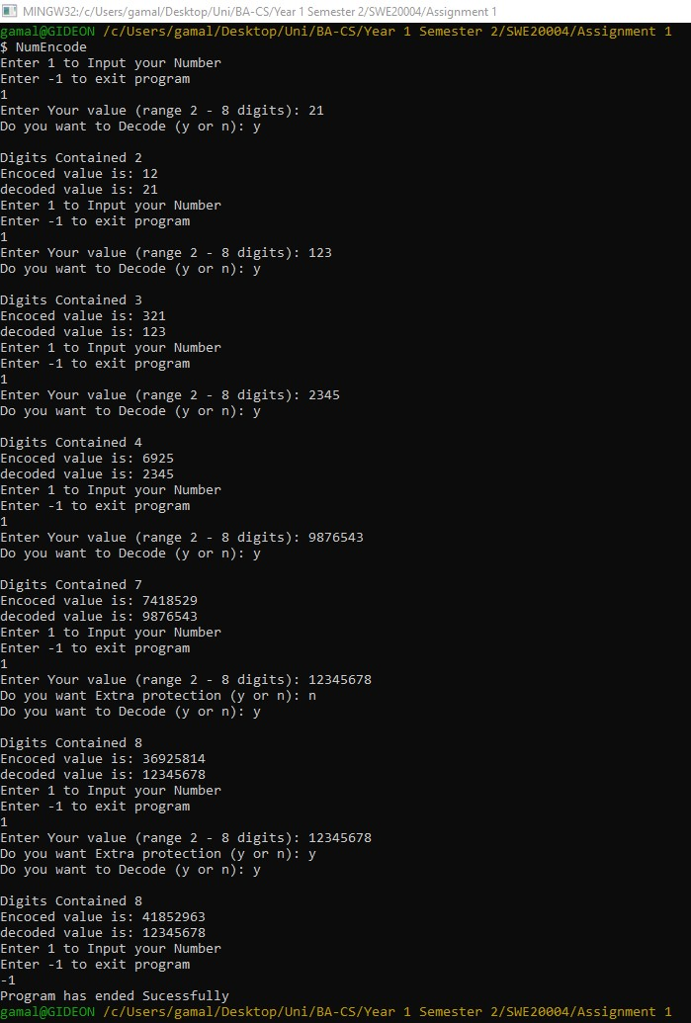

Task 2.11

Program description

This program is used to calculate the Voltage Gain Depending on the frequency and the number of stages in the amplifier

Source Code
- #include <iostream>
- #include <string>
- #include <cmath>

- using namespace std;

- int main()
- {
- float Voltage_Gain = 0, f, n;
- cout<<"Enter the frequency"<<endl;
- cin>>f;
- cout<<"Enter the Number of stages in the amplifier"<<endl;
- cin>>n;
- Voltage_Gain = pow(275/sqrt(pow(23,2)+(0.5*pow(f,2))), n);

- cout<<"At Frequency of "<<f<<" hertz, the Voltage gain is "<<Voltage_Gain<<endl;
- return 0;
- }

Screenshots showing working program
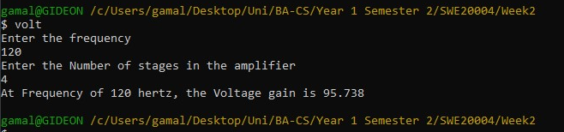

Task 3.8

Program description
Stores the Users PC information

Source Code

#include<iomanip>
#include<iostream>
#include<string>
#include<math.h>

using namespace std;

bool validateString(string s);
bool validateSize(string s);

int main()
{
string SerialNumber, username, EmpName, MAC;
char PcType;
unsigned int cores;
float CPUspeed;
int IPV4_address[4] = {0};
bool ValidString = true, validsize = true, validnum = true ;

//PC Serial Number
cout<<"Please enter your PC Serial Number (AlphaNumeric no spaces): ";
getline(cin, SerialNumber);
ValidString = validateString(SerialNumber);
validsize = validateSize(SerialNumber);

while(ValidString == false||validsize == false)
{
if (ValidString == false)
{
cout<<"This is an invalid statement, Please follow the given format (AlphaNumeric no spaces): ";
getline(cin, SerialNumber);
ValidString = validateString(SerialNumber);
}

if (validsize == false)
{
cout<<"This is an invalid statement, Please follow the given format (AlphaNumeric no spaces): ";
getline(cin, SerialNumber);
validsize = validateSize(SerialNumber);
}

}
//Username
cout<<"Please enter your UserName (AlphaNumeric no spaces): ";
getline(cin, username);
ValidString = validateString(username);
validsize = validateSize(username);

while(ValidString == false||validsize == false)
{
if (ValidString == false)
{
cout<<"This is an invalid statement, Please follow the given format (AlphaNumeric no spaces): ";
getline(cin, username);
ValidString = validateString(username);
}

if (validsize == false)
{
cout<<"This is an invalid statement, Please follow the given format (AlphaNumeric no spaces): ";
getline(cin, username);
validsize = validateSize(username);
}

}

//Emp Name
cout<<"Please Enter your name: ";
getline(cin, EmpName);

//PC type
cout<<"Please Enter your PC type(S=server, D=desktop, L=laptop, T=tablet, P=phone): ";
cin>>PcType;

//Number of Cores
cout<<"Please Enter the number of cores: ";
cin>>cores;

//CPU frequency
cout<<"Please enter the CPU speed: ";
cin>>CPUspeed;

//MAC address
cout<<"Please Enter your mac address: ";
cin>>MAC;
if (MAC.length() != 16)
{
cout<<"This is an invalid statement, Please follow the given format (16 Digit Hex MAC Address): ";
cin>>MAC;
validsize = true;
}
while(validsize == false)
{
cout<<"This is an invalid statement, Please follow the given format (16 Digit Hex MAC Address): ";
cin>>MAC;

}

//IP Address
cout << "Please enter the IPV4 address without the dots (e.g. 111 222 333 444):" << endl;
for(int i = 0;i<4;i++)
{
cin>>IPV4_address[i];
}

cout<< setw(50) << setfill('-') << "+" << endl;
cout<< "| User: " << username << " | Employee: " << EmpName << " | Serial: " << SerialNumber <<" |"<< endl;
cout<< setw(50) << setfill('-') << "+" << endl;
cout<< "| PC Type: " << PcType << " | Cores: " << cores << " | CPU Speed: " << CPUspeed << " | MAC:" << MAC << " | IP: ";
for (int i = 0; i < 4; i++)
{
cout << IPV4_address[i];
if (i != 3)
{
cout << ".";
}
}
cout<<" |"<<endl;
cout<< setw(50) << setfill('-') << "+" << endl;

//IP to INT
unsigned long int ip_interger = (IPV4_address[0]*(pow(256., 3))) + (IPV4_address[1] * (pow(256., 2))) + (IPV4_address[2] * 256) + IPV4_address[3];
cout << "iP address as interger: " << ip_interger << endl;

return 0;
}

bool validateString(string s)
{
for (auto c : s) //auto decides the data type depending on what data is stored part of cpp v11 could have used an if statement before to decide the data type but extra work
{ // might not be compatible with all compilers (older compliers)
if (!isalnum(c))
{
return false;
}

if(isspace(c))
{
return false;
}
}

return true;
}

bool validateSize(string s)
{
if (s.length() != 10)
{
return false;
}
return true;
}

Screenshots showing working program
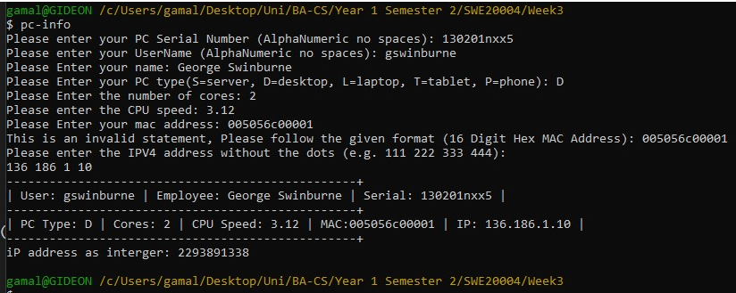

Task 4.9

Program description

Uses logic statements to determine what the user does depending on the conditions

Source Code

#include <iostream>
#include <string>

using namespace std;

int main()
{
char ans;
int DayOfWeek, i = 0;
bool validDay = true, ValidAns = true;
do {
do {
cout << "What day is it (Sunday = 1): ";
cin >> DayOfWeek;
if (DayOfWeek <= 0 || DayOfWeek >= 8)
{
cout << "This is not a valid day" << endl;
validDay = false;
}
else
{
do {
cout << "Is it Raining (y or n): ";
cin >> ans;
if (tolower(ans) == 'y')
{
if (DayOfWeek != 1 && DayOfWeek != 7)
{
cout << "Go out and Take an Umbrella" << endl << endl;
}
else
{
cout << "Read in bed" << endl << endl;
}
i++;
}
else if (tolower(ans) == 'n')
{
if (DayOfWeek != 1 && DayOfWeek != 7)
{
cout << "Go Out" << endl << endl;
}
else
{
cout << "Go out" << endl << endl;
}
i++;
}
else
{
cout << "Please make a choice based on the following(y or n): ";
ValidAns = false;
}
} while (ValidAns != true);
}
} while (validDay != true);
} while (i != 7);

return 0;
}

Screenshots showing working program

